**National Hydrology Project**



NAGALAND State   
Project Implementation Plan

Implementing Agencies

IRRIGATION & FLOOD CONTROL DEPARTMENT

Table of Contents

Summary 4

1 BACKGROUND: Water Resources 5

1.1 State at A Glance 5

1.3 Description of River Basins………………………………………………………………......7

1.4 Description of GroundWater Aquifers 7

1.5 Existing Hydro-met Monitoring System in the state 8

1.6 Overall Organogram of the State’s Existing Water Resources Management Set up 9

1.7 Details of Ongoing Programs in the Water Sector 10

2 Water Resources Management Issues 11

2.1 Surface Water management ISsues 11

2.2 Surface Water Quality ISsues 11

2.3 GroundWater management ISsues 12

2.4 GroundWater Quality ISsues 12

3 Overview of Project activities 12

3.1 water management issues to be addressed under National Hydrology project 12

3.2 Project Objectives: Main purpose of the proposed program. 12

3.3 Project Success Indicators: 3-5 main results/ outcomes indicators to measure the Success of the project. 13

3.4 Description of the Components and Sub-Components 13

3.4.1 Component A: Hydromet Informatic System 13

3.4.2 Hydromet Observation Network 13

3.4.3 Real time data acquisition and database management system 14

3.4.4 Hydro-informatics Data center 15

3.5 Component B: National Water Information Centre 15

3.5.1 Wed-based State-WRIS 16

3.5.2 Digitization of Maps and Documents 16

3.5.3 Development of spatial river basin information system including thematic maps etc. 17

3.6 Component C: Water Resources Operations and Planning 16

3.6.1 DSS for Flood and Water Management in River Basin 17

3.6.2 Irrigation operation and management system 17

3.6.3 Groundwater Management 18

3.7 Purposed Driven Studies 19

3.7.1 Component D: Water Resources Institutions and Capacity Building 19

4 IMPlementation Arrangements 20

4.1.1 Overall Project Management 20

4.1.2 Implementation Responsibilities 25

4.2 PROJECT MONITORING 26

4.2.1 Key Project Indicators to measure the success of the project 26

4.2.2 Overall Monitoring Framework 26

4.3 Ecnomomic and Finanial Analysis 26

4.4 First year annual plan 27

4.4.1 First Year Implementation Plan 27-28

4.4.2 First Year Capacity Building Plan 28

4.4.3 First Year Procurement Plan 29-30

4.4.4 First year Disbursement Plan 30

Appendix-1:Organizational Chart of Department for implementation of NHP…………...31

Appendix-2(i):State Govy. Notification for setting up of Hydro Informatic Cell(SPMU)…………32

Appendix - 2(ii): Composition of SPMU…………………………………………………………33-34

Appendix-3: SPMU Chart……………………………………………………………… .…………….35

# Summary

|  |  |  |  |
| --- | --- | --- | --- |
| **S.No.** | | **Parameter** | **Description** |
| **1** | | **implementing agency** | **IRRIGATION & FLOOD CONTROL DEPARTMENT,**  **NAGALAND** |
| **2** | | **Nodal Officer** | **er. NJILO KEMP, CHIEF ENGINEER, IRRIGATION & FLOOD CONTROL DEPARTMENT nagaland** |
| **3** | | **contact details** | **office of the chief engineer, irrigation & flood control, nagaland, kohima,**  **new capital complex, below nagaland civil secretariat. pin: 797001 tel: 0370-2270923** |
| **4** | | **Summary** | 1. **Upgrading of 27 existing Gauge & Discharge Sites with Automatic Water Level Recorder (AWLR) and telemetry based INSAT/GSM. In addition, 5 nos of new Gauge and Discharge Telemetry based Stations attached with Automatic Water Level Recorder (AWLR) and Automatic Rain Gauge (ARG)** 2. **setting up of 9 nos of Automatic Rain Gauge (ARG) station at allthe district headquarter offices of the department.** 3. **Setting up of 5 Automatic Weather Station (AWS) in the irrigation potential valleys of the State alongside the existing manual rain gauge stations installed by the dept of irrigation & flood control and 1 Automatic Weather Station (AWS) at the proposed SDC, Kohima.** 4. **Setting up of State Data Centre cum Informatics Centre at the State capital. HP Convention Center with Soil & Water Quality Testing Lab will be set up in Dimapur. All districts will have Hydrology Cell in the Divisional Offices.** 5. **River BASIN PLANNING MODELLING FOR 9 RIVER BASINS namely:- CHATHE-DZUZA, DHANSIRI, DOYANG, TSURANG, MILAK, TIZU, DIKHU, BARAK & TIZIT.** 6. **BENCHMARKING OF MINOR IRRIGATION PROJECTS IMPLEMENTED IN THE STATE.** |
| **5** | **Financial Outlay** | | |

|  |  |  |  |  |
| --- | --- | --- | --- | --- |
|  | **Project Component** | **(in Crore INR)** | | |
|  | **World Bank** | **Government** | **Total** |
|  | Hydromet Informatic System (HIS) | **16.80** | **0.00** | **16.80** |
|  | National Water Information Center | **1.40** | **0.00** | **1.40** |
|  | Water Resources Operation and Planning | **4.20** | **0.00** | **4.20** |
|  | Institutions and Capacity Building | **5.60** | **0.00** | **5.60** |
|  | **TOTAL** | **28.00** | **0.00** | **28.00** |

# BACKGROUND: Water Resources

## State at A Glance

| **S. No.** | **Description** | **Details** |
| --- | --- | --- |
| **General** | | |
|  | Geographical Area (km2) | 16579 |
|  | Population (Crores 2011 census) | 0.198 |
|  | Number of district | 11 |
|  | Number of Blocks | 74 |
| **Water Resources** | | |
|  | Major Rivers | Dhansiri, Doyang, Dikhu, Tizu |
|  | River Basins (No and Name) | Brahmaputra Basin, Barak Basin, Chindwin-Irrawady Basin |
|  | Number of sub-basins* | 9 |
|  | Rainfall (Lakh Ha-m) | 37.30 |
|  | Surface Water (Lakh Ha-m) | 17.53 |
|  | Ground Water, (Lakh Ha-m) | 1.95 |
|  | Number of over exploited blocks | Not Available |
|  | Number of blocks with water quality issues | Not Available |
| **Hydromet Monitoring System** | | |
|  | Number of Meteorological stations | 53 |
|  | Number of River Gauging | 27 |
|  | Number of GW monitoring stations | Not Available |
| **Storage Structures** | | |
|  | Number of Major and medium Reservoirs | 0 |
|  | Number of Major and medium Barrages | 0 |
|  | Existing Storage of Reservoirs (MCM) | 565 |
|  | Hydropower generation (MW) | 100.34 |
|  | Actual Irrigated Area (lakh ha) | 0.973 |
|  | Rainfed area (Lakh ha) | 2.28 |
|  | Flood Affected Area (Lakh ha) | 0.10 |
|  | Drought affected area (Lakh ha) | Not Available |
| **Institutional Setup** | | |
|  | River Basin Organization | Nil |
|  | Division for Hydromet monitoring | 1 |
|  | Existing River basin modelling capabilities in the state | Nil |
|  | Status of State Water resources information system and existing data sharing system | Nil |
|  | Flood center | Nil |
|  | Planning and design unit | Nil |
|  | Training Institution | Nil |
| Note: * list of Basin and sub-basins codes is provided in on project website. | | |

## 1.3 Description of River Basins

| **Sub-Basin Code** | **Name of River Basin/Sub-Basin** | | **Whether Interstate** | | **Drainage Area** | **Number of Storage Structures** | | **Hot Spots/ Issues** |
| --- | --- | --- | --- | --- | --- | --- | --- | --- |
|  | **Basin** | **Sub-Basin** | **Yes/No** | **% within State** | **(km2)** | **Type** | **Number** |  |
| 2B | Brahmaputra | Dhansiri (South) | Yes | 17.5 | 8405 |  |  | Flood, River Pollution |
| Chathe-Dzuza | No | 100 | 621 |  |  | Flood, Irrigation |
| Doyang | No | 100 | 3558 | Rockfill (for hydel only) | 1 | Irrigation, Drinking,Hydro power |
| Tsurang (Bhogdoi) | No | 34.9 | 1420 |  |  | Flood, Irrigation |
| Milak (Jhanji) | No | 65.6 | 1349 |  |  | Irrigation |
| Dikhu | No | 69.3 | 4372 |  |  | Irrigation |
| Tizit (Disang) | No | 21 | 3950 |  |  | Irrigation |
| 2C | Barak | Barak | No | 3.1 | 26193 |  |  | Irrigation |
| 22 | Chindwin- Irrawady | Tizu | No | 100 | 4884 |  |  | Irrigation, Navigation |

## Description of GroundWater Aquifers

| Sub-Basin code | Aquifer Name | Type and Description | Annual Recharge (million m3) | Current Utilization (million m3) | Major Use of Water from the Aquifer | Major Issues |
| --- | --- | --- | --- | --- | --- | --- |
|  |  | Not Available as of now.  To be reported as and when information are available from State Geology & Mining Deptt |  |  |  |  |

## Existing Hydro-met Monitoring System in the state

Following is the summary of existing setup. The detailed are provided in Annexure…

|  |  |  |  |  |  |  |  |  |  |  |  |  |  |  |
| --- | --- | --- | --- | --- | --- | --- | --- | --- | --- | --- | --- | --- | --- | --- |
| **S.. No.** | **Type** | **State** | | | **CWC** | | | | **IMD** | | | **Others** | | |
| P | S | **T** | P | | S | **T** | P | S | **T** | P | S | **T** |
| 1. | Meteorological  (Rain gauge/  AWS/FCS) | 22 |  | **22** |  | |  | **0** | 10(AWS  & 14 ARG) |  | **24** | 8 |  | **8** |
| 2. | River Gauge | 27 | | **27** |  | | | **0** |  |  | **0** |  | | **0** |
| 3 | Water Quality in Rivers |  |  |  |  |  | | **0** |  |  | **0** |  | | **0** |
| 4 | Ground water |  |  |  |  |  | | **0** |  |  | **0** |  | | **0** |
| 5 | Water Quality in GW |  |  |  |  |  | | **0** |  |  | **0** |  | | **0** |

* P = Perennial S = Seasonal T = Total HOS = Hydrological Observation Station

#### Data Transmission and Storage

* *Describe the current transmission system if organized along with Issues & Constraints*

: All the 22 Meteorological Stations installed and operated by the State Department (17 Nos by Soil & Water Conservation Department, and 5 Nos by Irrigation & Flood Control Department) are of Manual type and are collected by engaging Meteorologist for daily collection, whereas those 24 Stations operated by IMD in the State are of ARG & AWS Type and are collected by them through Telemetry. The Datas collected by IMD are not made available to the State Department, and has to manually click in their web site daily for taking the datas. The State Department compiles the data and makes yearly publication in booklet form.

All the 27 Nos of Gauge & Discharge Stations are installed by Irrigation & Flood Control Department, and are manually operated by engaging Gauge Readers. Gauge Readers submits the datas monthly in hard copies, and Officer-in-charge checks and enters the data in the P.C for record and use. Telemetry is yet to be introduced. The State Department compiles the data and makes yearly publication in booklet form.

#### Data Sharing

* *Describe the current data sharing program (including where and how the data is shared among divisions, stakeholders and public. Also define the Issues and Constraints*

: Hydro-Meteorological datas available with the State Departments are shared amongst the Stakeholders and other Users such as Irrigation & Flood Control Deptt, Agriculture Deptt, PHED, Power, Railways etc on written request indicating their need and types of datas required. Datas are made available in hard copies. However the datas from those Stations operated by IMD are not accessible by the State.

#### Existing Flood forecasting system

* *Describe the existing flood forecasting setup including how the information flow from and to the field,*

: The State is yet to install any flood forecasting set-up.

#### Existing Reservoir Operation system

* *Describe the existing flood forecasting and reservoir operation system information flow from and to the field,*

: The State is yet to install any reservoir operation system.

## Overall Organogram of the State’s Existing Water Resources Management Set up

*[Clearly show all entities, cells, divisions, reporting relationships, number of technical/ professional staff at each level]*

Table 3: Existing departments associated with Water Resources Planning and Operation

| **Sl. No.** | **Task** | **Department responsible** | **Number of Technical personnel assigned** |
| --- | --- | --- | --- |
| 1 | Planning and Design Department | 1. Irrigation & Flood Control, 2. Soil & Water Conservation, 3. Geology & Mining, 4. Public Health Engineering, | Respective Departments have their own Cells with officers in the rank of S.E, E.E, A.E & J.E. |
| 2 | Hydrological monitoring | 1. Irrigation & Flood Control, 2. Soil & Water Conservation | 1. 4 Officers 2. 2 Officers |
| 3 | Canal and reservoir monitoring | Irrigation & Flood Control, | All E.Es of 11 Districts of the State |
| 4 | Flood forecasting center |  | NA |
|  | Groundwater Management | Geology & Mining | NA |
| 4 | Training | Respective Department undertakes its own training courses | NA |
| 5 | Research center |  | NA |
| 6 | River Basin/WRM modeling | NA | NA |

## Details of Ongoing Programs in the Water Sector

| **Sl. No.** | **Main Implementing Agency** | **Supporting Agencies** | **Name of Project / Program / Scheme** | **Main Focus/ Objective** | **Geographic Coverage** | **Time Period** | | **Financial Allocation (INR Lakh)** | | **Main Areas of Investments** |
| --- | --- | --- | --- | --- | --- | --- | --- | --- | --- | --- |
| **From** | **To** | **Total** | **Per Year** |
| **1** | **Irrigation & Flood Control** | **No** | **AIBP** | **Construction of Minor Irrigation projects** | **Whole Area of the State** | **1999 -00** | **2014 -15** | **51795.0** |  | **Irrigation potential areas of the State** |
| **2** | **Irrigation & Flood Control** | **No** | **FMP** | **Anti-Erosion Works on Rivers with Critical in Nature.** | **Foot Hill Areas of the State (50%)** | **2001 -02** | **2014 -15** | **8478.8** |  | **Protection of urban areas, townships, industrial areas, NH, Railways, Telecom, etc** |
| **3** | **Irrigation & Flood Control** | **No** | **Hydrology** | **Collection of Meteo. & G&D Datas** | **Whole Area of the State** | **2012 -13** | **2014 -15** | **200.0** |  | **Major Rivers & Irrigation Potential valleys of the State** |

# 

# Water Resources Management Issues

## Surface Water management ISsues

| Sub-Basin Code | Name of River Basin/Sub-Basin | | Hot Spots/ Issues |
| --- | --- | --- | --- |
|  | Basin | Sub-Basin |
|  | Brahmaputra | Dhansiri (South) | Flood, Drainage & Bank Erosion, River Pollution |
|  | Chathe-Dzuza | Flood & Bank Erosion, Irrigation |
|  | Doyang | Irrigation, Drinking, Hydro power |
| 2B | Tsurang (Bhogdoi) | Flood& Bank Erosion, Irrigation |
|  | Milak (Jhanji) | Flood & Irrigation |
|  | Dikhu | Flood, Irrigation & hydel |
|  | Tizit (Disang) | Flood &Irrigation |
| 2C | Barak | Barak | Irrigation, |
| 22 | Chindwin- Irrawady | Tizu | Irrigation, Hydel |

## Surface Water Quality ISsues

| Sub-Basin Code | Name of River Basin/Sub-Basin | | Water Quality Hot Spots/ Issues |
| --- | --- | --- | --- |
|  | Basin | Sub-Basin |
| i. 2B  ii. 2C  iii.22 | Brahmaputra,  Barak,  Chindwin- Irrawady, |  | 1. Silt sediment load, river pollution from sewage & sewerage |

## GroundWater management ISsues

| Basin Code | Aquifer Name | Type and Description | Major Issues |
| --- | --- | --- | --- |
|  |  | Not Available |  |

## GroundWater Quality ISsues

| Basin Code | Aquifer Name | Type and Description | Major Groundwater Quality Issues (not included in Table 2.3) |
| --- | --- | --- | --- |
|  |  | Not Available |  |
|  |  |  |  |
|  |  |  |  |

# Overview of Project activities

## water management issues to be addressed under National Hydrology project

The major water resource issues that the Department of Irrigation and Flood Control wishes to address in HP-3 include: i. Quantifying the available Surface water and Ground water in the State through hydro-met networks,

ii. Planning & design of Water resources management.

## Project Objectives: Main purpose of the proposed program.

To strengthened the existing Hydro-Meteorological Networks and establish as strong and reliable Hydrological Information System that can be integrated and uploaded online to facilitate development of database for decision making in the management of water resources.

## Project Success Indicators: 3-5 main results/ outcomes indicators to measure the Success of the project.

1. Development of Data Acquisition System for all Hydro-Met Networks.
2. Development of State Data cum Informatics Center.
3. DSS and Flood Modeling / Warnings for flood prone area.
4. State Water Resource Management Plan.

## Description of the Components and Sub-Components

### Component A: Hydromet Informatic System

### Hydromet Observation Network

**Establishment of**

| S.No. | Type of Station | Subtype | Type of Telemetry | Agency | | Agency 2 | | Total | | | Total cost |
| --- | --- | --- | --- | --- | --- | --- | --- | --- | --- | --- | --- |
|  |  |  |  | New | Up-gradation |  |  | New | Upgrade | Grand Total | (INR lakh) |
| 1 | Rain Gauge |  |  | 14 | 0 |  |  | 14 | 0 | 14 | **21.00** |
| 2 | Automatic Weather Stations |  | GSM | 6 | 0 |  |  | 6 | 0 | 6 | **90.00** |
| 3 | River Gauging | G |  |  |  |  |  |  |  |  |  |
| GD | GSM/ INSAT | 5 | 27 |  |  | 5 | 27 | 32 | 232.00 |
| GDQ |  |  |  |  |  |  |  |  |  |
| GDS |  |  |  |  |  |  |  |  |  |
| GDSQ |  |  |  |  |  |  |  |  |  |
| **River Gauging Total** |  | **5** | **27** |  |  | **5** | **27** | **32** | **232.00** |
| 4 | Groundwater | Construction of observation wells |  | 10 | 0 |  |  | 10 | 0 | 20 | 20 |
| DWLR |  |  |  |  |  |  |  |  |  |
| Water quality probes |  |  |  |  |  |  |  |  |  |
|  | **Grand Total** |  |  |  |  |  |  |  |  |  | **363.00** |

**G: Gauge, D: Gauge Discharge, Q: Quality, S: Sedimentation**

### Real time data acquisition and database management system

1. Provide dataflow from STATE-District. : NA
2. Provide dataflow of interstate basin (if any) : NA
3. Type of telemetry proposed

|  |  |  |  |  |  |  |
| --- | --- | --- | --- | --- | --- | --- |
| S. No. | Type | Type of Storage | Number of Stations | Duration  (years) | Storage | |
|  |  |  |  |  | Station years | Size (MB) |
| 1 | Surface water/Ground water | Manual Data |  |  |  |  |
| 2 | Surface Water | SWIS |  |  |  |  |
| 3 | Groundwater | GWIS/GEMS or equivalent software |  |  |  |  |
| 4 | Surface water/Ground water | Excel or equivalent format | 27 | 2 | 2 | 20 |
|  | **Total** |  | **27** | **2** | **2** | **20** |

### 

### Hydro-informatics Data center

| State | Type | Location | New/Renovations | Cost (INR lakh) |
| --- | --- | --- | --- | --- |
|  | RCC | Kohima (SDC) | New | 35.00 |
| Dimapur (HCC) | New | 155.00 |
|  |  |  |
|  |  |  |
|  |  |  |
| **Grand Total** |  |  |  | **190.00** |

## Component B: National Water Information Centre

(Provide existing setup and plan for strengthening SWRIS. How different information will be updated. Also list how SWRIS will be customized for various stakeholder/districts /projects etc. how information will be collected from various stakeholders)

Presently the Department of Irrigation & Flood Control is monitoring 27 manual Gauge & Discharge Station and 5 Meteorological Station in the State. The daily datas are collected by the Gauge Reader and Meteorological stationed at the site and the monthly datas are reported to the Department for data validation, data entry, compilation & publication.

Soil & Water Conservation Department is also monitoring 17 manual Meteorological Stations. NIC Nagaland has developed and hosted a web based application ‘Weather Information System’ for the Soil and Water Conservation Department. The Soil Department first collects the daily datas from their Meteorological Stations situated in different parts of the State via text SMS through their Staff deployed for the purpose. Then the compiled datas are forwarded to NIC for uploading into their portals. Citizens can access this information from the links provided on the state government portal.

Under NHP the two Departments will coordinate for collection of all Hydro- Meteorological datas through manual/telemetry and set up a State data centre for the purpose and simultaneously link up the hydro-met datas to State NIC for uploading into their portal to strengthen the SWRIS. Accordingly all basic information on Hydro-Meteorological aspect is intended to be uploaded & updated regularly.

### Wed-based State-WRIS

General description of the plans along with Cost (Lakh INR)

Once the sufficient data are collected from all the respective Hydro-Met station the datas will be process / validated and through a web-based programs/application citizens can access information anytime. Provision of Rs.115.00 lakhs has been earmarked for the purpose.

### Digitization of Maps and Documents

Identify the of Maps and documents and link the same to River Basin along with Cost (Lakh INR)

: Not assessed

### Development of spatial river basin information system including thematic maps etc.

Identify the of Maps (detailing which River Basin it belongs to) with Cost (Lakh INR)

: Not assessed

## Component C: Water Resources Operations and Planning

Provide summary of main activities in this component.

Preparation of River Basin Planning modeling for 9 river basin, Formulation of State Water policy and Studies on Assessing water quality & waste load, river pollution of Dhansiri river within Dimapur Town. Benchmarking of minor irrigation projects implemented in the State and PDS Studies for sedimentation& erosion for the State.

### DSS for Flood and Water Management in River Basin

| Sub-Basin Code | Basin | Sub-basin | Issues | Type of Application | Division carrying out the application | Arrangement for sharing Analytical Outputs | Cost (INR lakh) |
| --- | --- | --- | --- | --- | --- | --- | --- |
|  | *Brahmaputra* | *Dhansiri &*  *Chathe-Dzuza* | *{Flood}* | *Flood forecasting* |  |  |  |
| *2B* | *Water allocation* | Operationalization of Flood forecasting model for Dhansiri | Investigation Cell, I&FC, Dimapur, Nagaland |  | 50.00 |
|  |  |  |  |  |  |
|  | *{Sub-basin 1b}* | *Drought* | *Drought forecasting* |  |  |  |
|  |  |  |  |  |  |
|  |  |  |  |  |  |
|  | *{Sub-basin 1c}* |  |  |  |  |  |
|  |  |  |  |  |  |

### Irrigation operation and management system

| Basin/  Sub-Basin code | Basin | Sub-Basin | Command area  (Lakh Ha) | Type of Application | Division carrying out the application | Anticipated benefits) | Cost (INR lakh) |
| --- | --- | --- | --- | --- | --- | --- | --- |
|  | Not Applicable |  |  |  |  |  |  |
|  |  |  |  |  |  |
|  |  |  |  |  |  |
|  |  |  |  |  |  |
|  |  |  |  |  |  |
|  |  |  |  |  |  |
|  |  |  |  |  |  |

SCADA systems for Reservoir Operation

| Basin/  Sub-Basin code | Basin | Sub-Basin | Name Reservoirs/ Barrage | Number of Gates | Command Area (Ha) | Hydropower Generation (Ha) | Anticipated benefits) (Flood affected area etc) | Cost (INR lakh) |
| --- | --- | --- | --- | --- | --- | --- | --- | --- |
|  | Not Applicable |  |  |  |  |  |  |  |
|  |  |  |  |  |  |  |
|  |  |  |  |  |  |  |
|  |  |  |  |  |  |  |
|  |  |  |  |  |  |  |
|  |  |  |  |  |  |  |

### Groundwater Management : Not Available

[ Please provide list of details and anticipated benefits along with Cost]

## Purposed Driven Studies

[ Please provide list of PDS proposed along with issues and anticipated benefits along with cost].

|  |  |  |  |  |  |
| --- | --- | --- | --- | --- | --- |
| **Sl no** | **PDS Topic** | **Rational**  **(Key issue)** | **Division responsible for carrying out** | **Anticipated benefits** | **Cost (INR lakh)** |
| 1 | River Basin Planning modelling for 9 river basin | Water resource planning | C.E Office & E.E Investigation Cell, I&FC, Dimapur | All water resources related dept for planning & design of projects | 200.00 |
| 2 | Benchmarking of minor irrigation projects implemented in the State |  | CE Office & Investigation Cell, I&FC, Dimapur | Utilization of irrigation potential created | 50.00 |
| 3 | PDS studies for sedimentation& erosion for the State | Silt load | Investigation Cell, I&FC, Dimapur |  | 60.00 |
| 4 | PDS for Assessing water quality & waste load, river pollution of Dhansiri river within Dimapur Town | Water Quality | Investigation Cell, I&FC, Dimapur | Preserving the River from pollution | 30.00 |
| 5 | PDS studies for urban flooding for Chathe-Dzuza & Dhansiri basins within Dimapur Town | flood | Investigation Cell, I&FC, Dimapur | To mitigate the Problem of Flood and Drainage within Dimapur Town | 30.00 |

### Component D: Water Resources Institutions and Capacity Building

[ Please provide list of proposed training, number of beneficiaries etc. along with cost]

Incremental staff cost during for a period of 8 years including hiring of expert and technician.

|  |  |  |  |
| --- | --- | --- | --- |
| **Sl no** | **Trainings/study tour** | **No. of Beneficiaries** | **Cost (INR lakh)** |
| 1 | Visit to other HP1 & HP2 | 20 | 25.00 |
| 2 | National level training | 20 | 40.00 |
| 3 | International tour/ training | 10 | 100.00 |

# 

# IMPlementation Arrangements

### Overall Project Management

|  |  |  |  |  |  |
| --- | --- | --- | --- | --- | --- |
| Coordinator  *[Name, Designation, Address and contact details including email ID]* | | Shri. Bendangkokba, (IAS),  Secretary to the Govt. of Nagaland,  Irrigation & Flood Control,  Nagaland Civil Secretariat, New Capital Complex  Kohima #797001  Tel: 0370-2271107 | | | |
| Is the Project Director Position is assigned Full time? | | | | Yes | |
| Nodal Office  *[Name, Designation, Address and contact details including email ID]* | | Er.S.Kughaho Sema, Chief Engineer,  Irrigation & Flood Control, Nagaland, Kohima,  New Capital Complex # 797001  Tel: 0370-2270923  Email: [kughaho83@gmail.com](mailto:kughaho83@gmail.com) | | | |
| Is the Project Coordinator Position assigned Full time? | | | | Yes | |
| **Composition and Deployment of Full time Core Team *[Number Of Technical/ Professional Positions]*** | | | | | |
| Number Planned | Number Redeployed | | Number filled On Deputation | | Number Hired on Contract |
| 5 | Not yet | | Not yet | | Not yet |
|  | | | | | |

[*Please provide Institutional Organization chart based on the structure provided below (SW or GW or both).

**Smaller states may reduce the number of staff for SPMU based on their PIP and budgetary allocation]

**Composition of SMPU-WRD/ SW\***

| **S. No** | **Positions under NHP-SPMU** | | **Required Number** | **Actual Number** | **Name; Designation and Division of Officer** | | **Remarks** |
| --- | --- | --- | --- | --- | --- | --- | --- |
| 1 | **Coordinator**  (Principal Secretary Level) | | 1 | 1 | Shri. Bendangkokba, (IAS), Secretary, Govt. of Nagaland, Irrigation & Flood Control, Kohima | |  |
| 2 | **Nodal Officer**  (Chief Engineer Level) | | 1 | 1 | Er.S. Kughaho Sema, Chief Engineer, Irrigation & Flood Control, Kohima | |  |
| 3 | **Superintending Officer/ Deputy Nodal Officer**  (Division where SPMU will be housed) | | 1 | 1 | Er.Tsuktinungsang, S.E  Circle-1, Irrigation & Flood Control, Dimapur, Nagaland | |  |
|  |  | | |  | | **Technical Sections** | |
| 4 | Sr. Water Management Expert  (EE Level or higher)- 1no. | 1 | |  | Er. Razouvolie Kelio,EE  Chief Engineer’s Office,  Irrigation & Flood Control  Nagaland, Kohima | |  |
| 5 | **Hydrologist**  (AEE Level for higher) 1 No. | 1 | | 1 | Er.Sobu Angami, E.E,  Investigation Cell, Irrigation & Flood Control, Dimapur | |  |
| 6 | **Modeller**  (AE/AEE) 2 Nos. | 2 | | 1 | 1. Er. Zatho, J.E  Investigation Cell, Irrigation & Flood Control, Dimapur  2. Er. Rokuobeinuo Mere,J.E  Investigation Cell, Irrigation & Flood Control, Dimapur | |  |
| 7 | **Hydro-met Instrumentation Expert**  (AE/AEE) 2 nos. | 2 | | 1 | 1. Er.Teiheile Hegeu, A.E, Investigation Cell, Irrigation & Flood Control, Dimapur  2. Er. Hetoi Kinny,A.E  Investigation Cell, Irrigation & Flood Control, Dimapur | |  |
| 8 | **Database Management Expert**  1 nos. | 1 | |  | Yet to identify | |  |
| 9 | **IT/ Web Designing Expert**  1nos | 1 | |  | Yet to identify | |  |
| 10 | **GIS Expert**  1 nos | 1 | |  | Yet to identify | |  |
| 11 | **Data Entry Operator**  2 nos. | 2 | | 2 | 1. Benthungo Humtso, Surveyor,  Invn Cell, I & FC, Dimapur  2. Inavi Shohe, Surveyor,  Invn Cell, I & FC, Dimapur | |  |
|  |  | | |  | | **Finance** | |
| 12 | **Accounts Officer**  1 nos | 1 | | 1 | 1. Shri. Tali Mungro,   Accounts Officer, C.E Office, Kohima | |  |
| 13 | **Asst. Accounts Officer**  1 nos. | 1 | | 1 | 1. Limasanen, Sr. D.A,   Invn. Cell,I & FC Dimaour | |  |
|  |  | | |  | | **Procurement** | |
| 14 | **Procurement Expert**  (Instrument/ IT related) 1 nos | 1 | | 2 | 1. Er. Hutovi Swu, E.E,  Chief Engineer’s Office,  Irrigation & Flood Control  Nagaland, Kohima  2. Er. Khriebeituo Kulnu, A.E  Chief Engineer’s Office,  Irrigation & Flood Control  Nagaland, Kohima | |  |
| 15 | **Procurement Expert**  (Goods and Consultancy) 1nos |  | |  |  |
|  |  | | |  | | **M & E** | |
| 16 | **MIS Expert**  1 nos. |  | |  | Er. Neizevonuo Mor, J.E  Chief Engineer’s Office,  Irrigation & Flood Control  Nagaland, Kohima | |  |
| 17 | **M & E Expert**  1 Nos. |  | |  | Yet to identify | |  |
| 18 | **Meteorological Officer** |  | | 1 | Mrs. Lochumi Venuh, Meteorologist,  Soil & Water Conservation Deptt. | |  |

**Composition of SMPU-GW* NOT APPLICABLE**

| **Sl. No** | **Positions under NHP-SPMU** | **Name; Designation and Division of Officer** | **Remarks** |
| --- | --- | --- | --- |
| 1 | **Coordinator**  (Principal Secretary Level) |  |  |
| 2 | **Nodal Officer**  (Director) |  |  |
| 3 | **Deputy Director**  (Division where SPMU will be housed) |  |  |
|  | **Technical Sections** | | |
| 4 | **Sr. Hydro-Geologist**  1 no. |  |  |
| 5 | **Geo-physics**  1 No. |  |  |
| 6 | **GW Modeller**  2 Nos. |  |  |
| 7 | **Hydro-met Instrumentation Expert**  (AE/AEE) 2 nos. |  |  |
| 8 | **Database Management Expert**  1 nos. |  |  |
| 9 | **IT/ Web Designing Expert**  1nos |  |  |
| 10 | **GIS Expert**  1 nos |  |  |
| 11 | **Data Entry Operator**  2 nos. |  |  |
|  | **Finance** | | |
| 12 | **Accounts Officer**  1 nos |  |  |
| 13 | **Asst. Accounts Officer**  1 nos. |  |  |
|  | **Procurement** | | |
| 14 | **Procurement Expert**  (Instrument/ IT related) 1 nos |  |  |
| 15 | **Procurement Expert**  (Goods and Consultancy) 1nos |  |  |
|  | **M & E** | | |
| 16 | **MIS Expert**  1 nos. |  |  |
| 17 | **M & E Expert**  1 Nos. |  |  |

*[Attach the Government Order approving the Institutional Model]*

***Attached as appendix 2***

### Implementation Responsibilities

*[For the main Component activities indicate the entity/positions primarily responsible for carrying out Financial management support, procurement support, Planning and execution, monitoring/quality control, Use of Information (only primary users within the main sector stake holders)]*

***Yet to assign***

| Component | Sub-component | Activity | Indicate the main responsible Institutions/Entities/ Positions | | | | |
| --- | --- | --- | --- | --- | --- | --- | --- |
| Financial Management | Procurement Support | Planning and Execution | Monitoring/ Quality Control | Using the Information/ Knowledge |
| Component 1 | Sub-Component 1.1 | Activity 1.1.1 |  |  |  |  |  |
| Activity 1.1.2 |  |  |  |  |  |
| Activity 1.1.3 |  |  |  |  |  |
| Sub-Component 1.2 | Activity 1.2.1 |  |  |  |  |  |
| Activity 1.2.2 |  |  |  |  |  |
| Activity 1.2.3 |  |  |  |  |  |
| Sub-Component 1.3 | Activity 3.1 |  |  |  |  |  |
| Activity 2.2 |  |  |  |  |  |
| Activity 3.3 |  |  |  |  |  |
| Component 2 | Sub-Component 2.1 | Activity 2.1 |  |  |  |  |  |
| Activity 2.2 |  |  |  |  |  |
| Activity 3.3 |  |  |  |  |  |

## PROJECT MONITORING

### Key Project Indicators to measure the success of the project

*[Mention 3-5 main results/ outcomes indicators using which the success of the project will be measured*

1. Development of Real Time Data Acquisition System for all Hydro-Met Networks.
2. Development of State Data cum Informatics Center.
3. DSS and Flood Modeling / Warnings for flood prone area.
4. River Basin Planning modeling for 9 river basin

### Overall Monitoring Framework

*[Describe how annual plans will be prepared, who will be responsible, approval mechanism]*

| Monitoring Tasks | Frequency | Primary Responsibility | Compilation Responsibility | Approval Responsibility | Deadline for Submission |
| --- | --- | --- | --- | --- | --- |
| Annual Planning | 6 months | Chief Engineer Office | EE in-charge of NHP | Chief Engineer | 31st March |
| Quarterly Progress Reports | 3 months | EE, Investigation Cell | EE, Investigation Cell | Chief Engineer | End of each Qtr |
| Annual Implementation Report | 12 months | EE, Investigation Cell | EE, Investigation Cell | Chief Engineer | 31st March |
| Learning, sharing and monitoring workshops | 6 months | Chief Engineer Office | EE in-charge of NHP | Chief Engineer | 30th Sept |

## Economic and Finanial Analysis

[Please provide IRR for major activities such as: impact on flood, benefit of SCADA, and design of major schemes if any planned.]

**: Not Applicable**

## First year annual plan

### First Year Implementation Plan

First Year action plan [include main tasks to be undertaken for initiating and carrying out project activities as planned for the first year]

|  |  |  |  |  |  |  |  |  |  |  |  |  |  |  |  |
| --- | --- | --- | --- | --- | --- | --- | --- | --- | --- | --- | --- | --- | --- | --- | --- |
| Sl. No. | Main Activities | Timeline [show bar chart against 12 months shown below] | | | | | | | | | | | | Responsibility | Remarks |
| 1st Qtr | | | 2nd Qtr | | | 3rd Qtr | | | 4th Qtr | | |
| 1 | 2 | 3 | 4 | 5 | 6 | 7 | 8 | 9 | 10 | 11 | 12 |
| 1 | RTDAS |  |  |  |  |  |  |  |  |  |  |  |  | Chief Engineer/ EE, Investigation Cell |  |
| 2 | Procurement of ADCP |  |  |  |  |  |  |  |  |  |  |  |  | -Do - |  |
| 3 | Handheld Flowmeter |  |  |  |  |  |  |  |  |  |  |  |  | -Do - |  |
| 4 | Vehicle mounted Crane |  |  |  |  |  |  |  |  |  |  |  |  | -Do - |  |
| 5 | Automatic Level |  |  |  |  |  |  |  |  |  |  |  |  | -Do - |  |
| 6 | GPS- Handheld |  |  |  |  |  |  |  |  |  |  |  |  | -Do - |  |
| 7 | Arc GIS |  |  |  |  |  |  |  |  |  |  |  |  | -Do - |  |
| 8 | Construction of State Data Centre @Kohima |  |  |  |  |  |  |  |  |  |  |  |  | -Do - |  |
| 9 | Construction of HP Convention Centre @Dimapur |  |  |  |  |  |  |  |  |  |  |  |  | -Do - |  |
| 10 | UPS Invertor(SDC) |  |  |  |  |  |  |  |  |  |  |  |  | -Do - |  |
| 11 | Generator(SDC) |  |  |  |  |  |  |  |  |  |  |  |  | -Do - |  |
| 12 | D.SLR, Handy Cam |  |  |  |  |  |  |  |  |  |  |  |  | -Do - |  |
| 13 | Purchase of 3 nos Laptops |  |  |  |  |  |  |  |  |  |  |  |  | -Do - |  |
| 14 | Purchase of 6 nos Desktop PC |  |  |  |  |  |  |  |  |  |  |  |  | -Do - |  |
| 15 | Purchase of computer Software & Accessories |  |  |  |  |  |  |  |  |  |  |  |  | -Do - |  |
| 16 | Purchase of Computer peripheral(scanner etc) |  |  |  |  |  |  |  |  |  |  |  |  | -Do - |  |
| 17 | Internet connectivity |  |  |  |  |  |  |  |  |  |  |  |  | -Do - |  |
| 18 | Purchase of 2 nos Vehicle |  |  |  |  |  |  |  |  |  |  |  |  | -Do - |  |
| 19 | Purchase of AO Printers 1 nos |  |  |  |  |  |  |  |  |  |  |  |  | -Do - |  |
| 20 | Hiring of Vehicle |  |  |  |  |  |  |  |  |  |  |  |  | -Do - |  |
| 21 | Hiring of Manpower |  |  |  |  |  |  |  |  |  |  |  |  | -Do - |  |

### First Year Capacity Building Plan

|  |  |  |  |  |  |  |  |  |  |  |  |  |  |  |  |  |  |  |
| --- | --- | --- | --- | --- | --- | --- | --- | --- | --- | --- | --- | --- | --- | --- | --- | --- | --- | --- |
| Capacity Building Event | Coverage of Topics | For Whom | Duration | Number of persons per batch | Number of Batches | By Whom | First year CB schedule | | | | | | | | | | | |
| 1 | 2 | 3 | 4 | 5 | 6 | 7 | 8 | 9 | 10 | 11 | 12 |
| Visit to other HP1 & HP2 | Hydro-met networks | Officers under NHP | 3 days per visit | 5 | 1 | Hydro-  Informatics Cell |  |  |  |  |  |  |  | 1 |  |  |  |  |
| National training | Hydro Meteorology | Officers under NHP | 3 days per training | 5 | 5 | Core Team members | 1 | 1 |  |  |  | 1 | 1 |  |  | 1 |  |  |

### First Year Procurement Plan

| Sl. No. | Contract Package Number | Contract Description | Total Value (Lakhs) | Qty/ Nos. | Estimated Price in Rs. lakhs | Procurement Method | Prior Review (Yes / No) | Planned Dates for | | | | Remarks |
| --- | --- | --- | --- | --- | --- | --- | --- | --- | --- | --- | --- | --- |
| Finalizing Bid Document | Inviting Bids | Bid Opening | Contract Signing |  |
| 1 |  | RTDAS | 343 |  | 343 | NCB |  | 1-07-17 | 8-07-17 | 8-09-17 | 8-10-17 |  |
| 2 |  | Procurement of ADCP | 50 | 2 | 50 | Direct Contracting |  | 1-07-17 | 8-07-17 | 8-08-17 | 23-08-17 |  |
| 3 |  | Handheld Flowmeter | 75 | 15 | 75 | Direct Contracting |  | 1-07-17 | 8-07-17 | 8-08-17 | 23-08-17 |  |
| 4 |  | Vehicle mounted Crane | 15 | 1 | 15 | Direct Contracting |  | 1-07-17 | 8-07-17 | 8-08-17 | 23-08-17 |  |
| 5 |  | Automatic Level | 8 | 16 | 8 | Direct Contracting |  | 1-07-17 | 8-07-17 | 8-08-17 | 23-08-17 |  |
| 6 |  | GPS- Handheld | 8 | 16 | 8 | Direct Contracting |  | 1-07-17 | 8-07-17 | 8-08-17 | 23-08-17 |  |
| 7 |  | Arc GIS | 40 | 2 | 40 | Direct Contracting |  | 2-01-17 | 9-01-17 | 9-02-17 | 23-02-17 |  |
| 8 |  | Laptop | 3.00 | 3 | 1.80 | Shopping |  | 1-04-17 | 8-04-17 | 8-05-17 | 30-05-17 |  |
| 9 |  | Computer Desktop | 15.00 | 10 | 6 | Shopping |  | 1-07-17 | 8-07-17 | 8-08-17 | 30-08-17 |  |
| 10 |  | Field Vehicle | 40.0 | 2 | 20.00 | Direct Contracting |  | 1-04-17 | 8-04-17 | 8-05-17 | 31-05-17 |  |
| 11 |  | SDC | 35.00 | 1 | 35 | Shopping |  | 2-01-17 | 9-01-17 | 24-2-17 | 25-03-17 |  |
| 12 |  | HPCC | 155 | 1 | 155 | NCB |  | 2-01-17 | 9-01-17 | 24-02-17 | 25-03-17 |  |
| 13 |  | Furnishing of SDC | 60 |  | 20 | Shopping |  | 1-07-17 | 8-07-17 | 8-08-17 | 30-08-17 |  |
| 14 |  | UPS invertor(for SDC&HCC) | 6 | 2 | 3 | Shopping |  | 1-07-17 | 8-07-17 | 8-08-17 | 30-08-17 |  |
| 15 |  | Generator(for SDC&HCC) | 30 | 2 | 15 | Shopping |  | 1-07-17 | 8-07-17 | 8-08-17 | 30-08-17 |  |
| 16 |  | D.SLR,Handy cam, | 6 | 2 | 3 | Shopping |  | 1-07-17 | 8-07-17 | 8-08-17 | 30-08-17 |  |
| 17 |  | Computer peripheral (scanner etc) | 7.50 |  | 2.00 | Shopping |  | 1-07-17 | 8-07-17 | 8-08-17 | 30-08-17 |  |
| 18 |  | Printer A0 | 15 | 2 | 15 | Direct Contracting |  | 1-07-17 | 8-07-17 | 8-08-17 | 23-08-17 |  |
| 19 |  | Purchase of computer Software & Accessories | 15.00 | 9 | 5 | Shopping |  | 1-07-17 | 8-07-17 | 8-08-17 | 30-08-17 |  |

### First year Disbursement Plan

| Sl. No. | Disbursement Category | Projected Disbursement (Rs. Lakhs) | | | | | Remarks |
| --- | --- | --- | --- | --- | --- | --- | --- |
| Quarter 1 | Quarter 2 | Quarter 3 | Quarter 4 | Total |
| 1 | Central Assistance | 65.20 | 92.00 | 359.77 | 64.22 | 928.74 |  |
| 2 | State Share | 0.00 | 0.00 | 0.00 | 0.00 | 0.00 |  |
| 3 | Total | 65.20 | 92.00 | 359.77 | 64.22 | 928.74 |  |

**Appendix-1: Organizational Chart of Department for implementation of NHP (Nagaland State)**

**(*Shaded portion indicates Officials to be directly involve for NHP)***

**Secretary (State Project Coordinator)**

**Chief Engineer (Nodal Officer)**

**Addl. Chief Engineer**

**Supdtt. Engineer-II**

**Supdtt. Engineer-I**

**S.E -Circle/Monitoring**

**(Dy. Nodal Officer)**

**E.E Invn Cell/Hydrologist**

E.E

**E.E-III (Procurement Expert)**

E.E-I

E.E-II

**SDO-II (Instrument Expert)**

**SDO-III**

J.E

SDO-I

SDO

**SDO-III**

SDO-I

SDO-II

**J.E**

J.E

J.E

**J.E**

J.E

**J.E**

E.E- Kma

E.E- Dmr

E.E- Llg

E.E- Prn

E.E- Wka

E.E- Mkg

E.E- Phk

E.E- Tsn

E.E- Mon

E.E- Zbt

E.E- Kph

SDO

SDO

SDO

SDO

SDO

SDO

SDO

SDO

SDO

SDO

SDO

JEs

JEs

JEs

JEs

JEs

JEs

JEs

JEs

JEs

JEs

JEs

**Appendix -2(i). State Government Notification for setting up of Hydro- Informatic Cell (SPMU)**

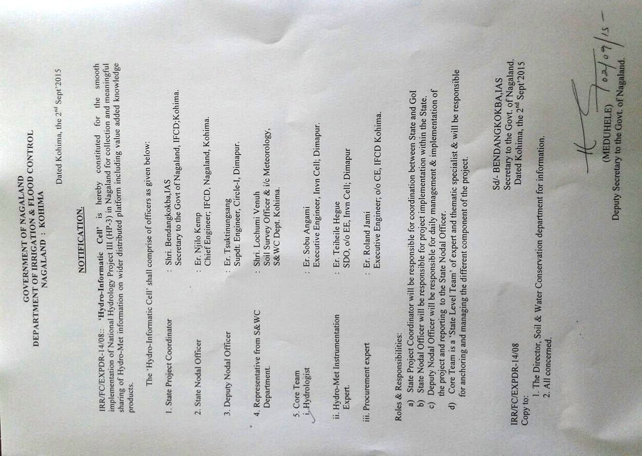

**Appendix -2(ii) SPMU Composition**

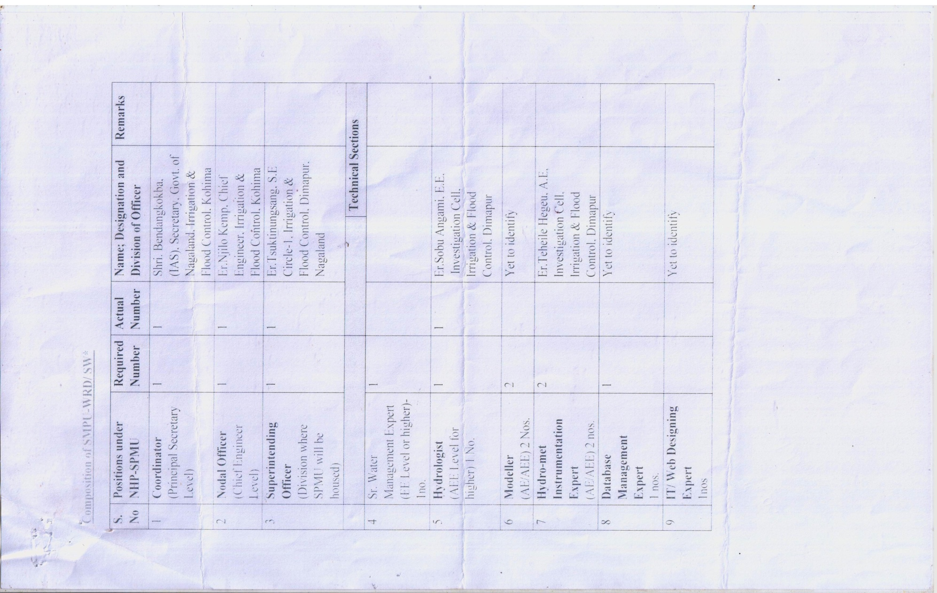

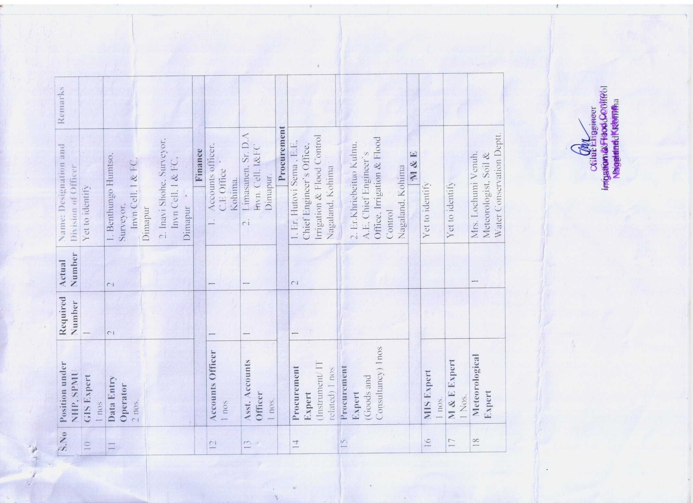

**ORGANOGRAM OF NAGALAND STATE PROJECT MANAGEMENT UNIT FOR NHP**

**STATE PROJECT COORDINATOR**

**(Secretary, Irrigation & Flood Control)**

**Nodal Officer**

**(Chief Engineer, I & FC)**

**Deputy Nodal Officer**

**(Superintending Engineer, I & FC)**

**Sr. Div. Assistant,**

**Invn. Cell**

**Accounts Officer,**

**C.E Office**

**Finance Cell**

**Meteorologist,**

**Soil & Water Conservation Deptt.**

**Procurement Expert**

**(A.E, I & FC, C.E Office)**

**Procurement Expert**

**(E.E, I & FC, C.E Office)**

**GIS Expert**

**(to be engaged)**

**MIS Expert**

**(to be engaged)**

**Data Entry Operator**

**(Invn. Cell, I & FC)**

**Modeller**

**(J.E, Invn. Cell, I & FC)**

**Instrumentation Expert**

**(A.E, Invn. Cell, I & FC)**

**Hydrologist**

**(E.E, Invn. Cell, I & FC)**

**MIS Cell**

**Meteorology Cell**

**Procurement Cell**

**E.E, Investigation Cell,**